
Land Information Ontario (LIO) Warehouse
Data Class Name: Natural Heritage System Area
Documentation
Produced by: Information Access and Information Management Policy Unit
Ministry of Natural Resources and Forestry
Date: November 24, 2015

Purpose

This document provides additional information to support the use of geospatial data. The Data Change History lists all the modelling and access changes that have occurred during the lifecycle of the data class.

Need Assistance?
Please contact LIO Support at lio@ontario.ca or 705-755-1878 if you require help.

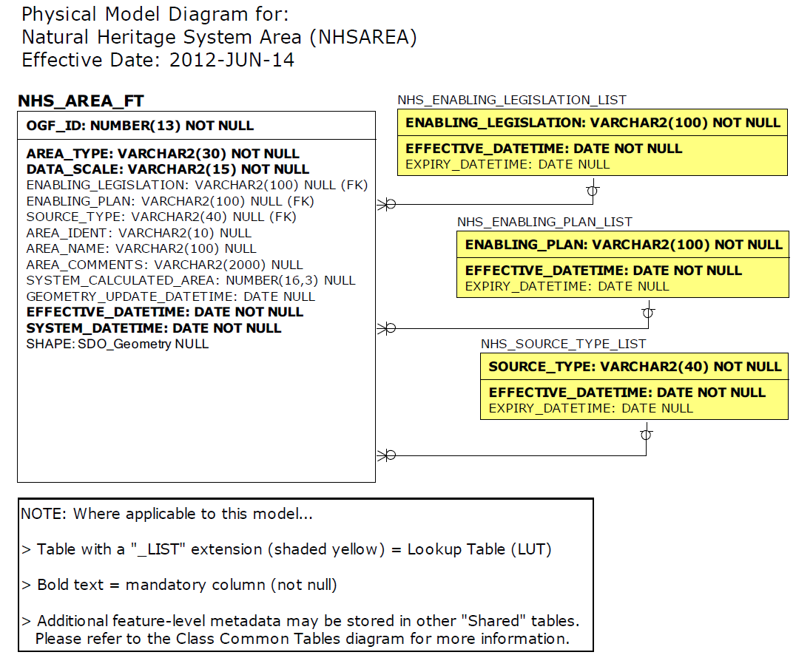
Data Description
Please refer to the metadata record for the data description.

